Clerks Report 5th December 2022

Midsomer Norton Town Hall Hoardings

Further to last month’s Clerks report illustrating the latest version of the three hoarding banners, which were on order to be put up at the Town Hall - they have now been installed (the photos show 2 hoardings but all 3 are in place). The large road sign which blocked the view to the side elevation of the Town Hall at the top of the High Street, has now also been removed.

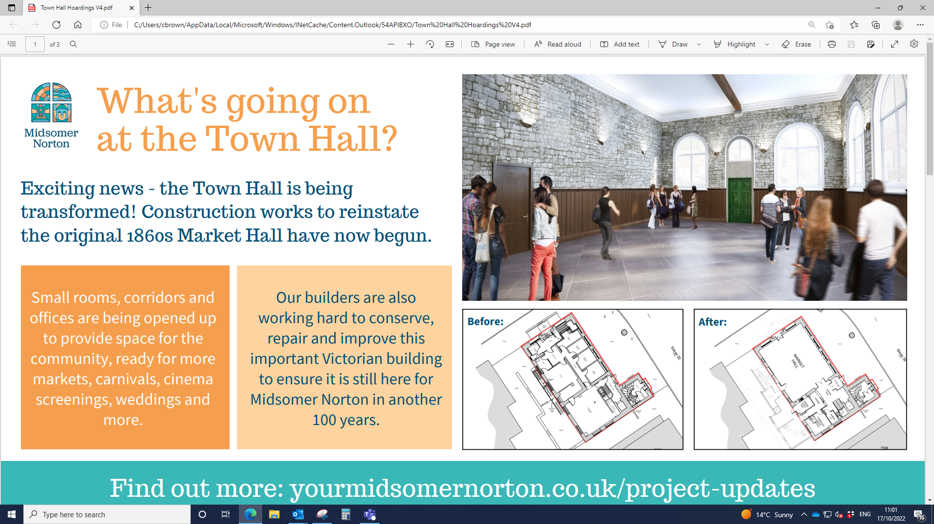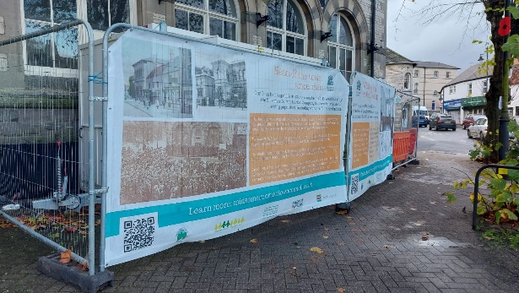

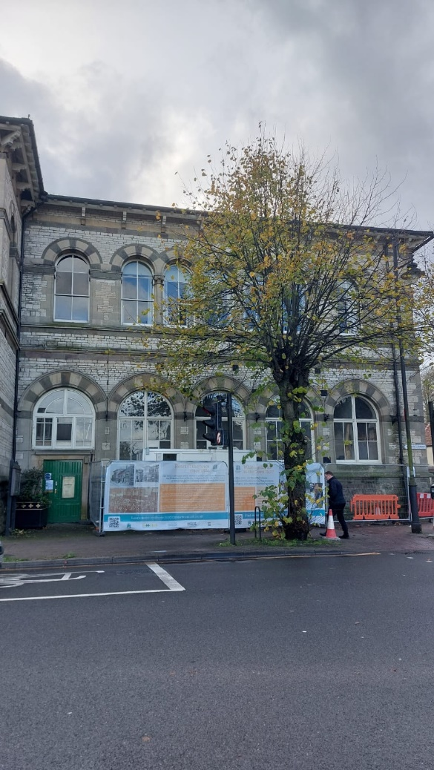

Letter of Complaint

We have received a letter of complaint from a resident regarding the online distribution of tickets for the Seniors Christmas Party. The resident has stated that the method of “applying via the website and printing off a ticket is completely discriminatory against the very people you are welcoming”.

The following response has been sent:

Thank you for contacting Midsomer Norton Town Council about your concerns resulting from the article in the Journal about the 2022 Senior Christmas Social.

Midsomer Norton Town Council are proud to offer free Christmas events for 4-11 year olds and teenagers as well as the Senior Social. We know that these different groups get their tickets in different ways, and traditionally the Senior tickets are booked in person or by telephone.

Collection in person for all events is not possible this year because the Town Council do not have office space in the Town Hall while it is being renovated. The new online booking system has been introduced this year to replace the option of booking face to face. The telephone booking system remained the same. The article in the journal did not list our telephone number, and this should have been included in the article to reassure readers that this option still existed.

The Town Council are aware that the need for home learning during COVID revealed that ten percent of families in the UK have no laptop, desktop or tablet in their home, largely due to financial constraints. And although the 2019 Census showed that, since 2011, the 65 to 74 years age group has seen the largest increase in recent internet use, the Town Council are aware that not everybody uses the internet or email. We know that there is a cost incurred to anyone attending any of our free events, be it the cost of a telephone call, the use the of technology or transport costs to pick up tickets or travel to events.

By lunchtime on the second day of sales we had given out 74 of the 80 free tickets for the Senior Christmas Social by telephone and through online orders. We started to receive phone calls at 7:30am on the day they were released, and calls continued into the evening. We know how popular the events are and are pleased that they are appreciated. Town Council officers were happy to assist anybody who needed support to secure their ticket.

We hope that this offers reassurance that Midsomer Norton Town Council have tried to accommodate the needs of all their residents to whom these free events are offered.

Please get in touch if you need any more information.

Wellow Brook Walk Signs

The first proofs for the interpretation signs to go each end at Wellow Brook Walk, have been received and sent out to all Councillors. Councillors have been asked for any comments to be received by Friday 25th November, after which amendments will be sought or progress to production.

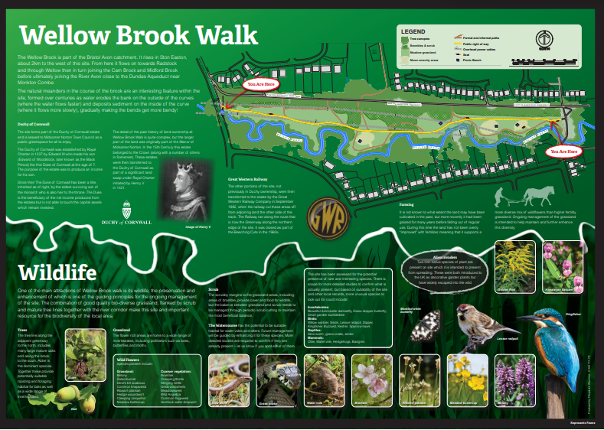

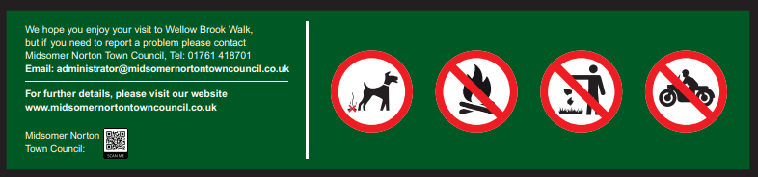

Parish Liaison Committee

Details of the following Parish Liaison Committee meetings - 15 March 2023 18:00-21:00, 19 July 2023 18:00-21:00, 18 October 2023 18:00-21:00 – have been sent to the following Councillor representatives - Michael Evans, Christian Griffiths and Steve Plumley.
Christmas Lights

The Community Trust have advised that they are of the opinion that the carols around the tree should not go ahead on Thursday 24th November. Unfortunately circumstances outside of everyone’s control have made this almost impossible to run effectively.

The Community Trust think the tree is great, the lights are confirmed/installed, leaving 6 days to organise, run and promote an event. Although it was only ever to be a small event, the Church have dropped out due to capacity, the Events team in B&NES aren’t comfortable with us promoting it at all, there’s a date clash with Westfield, a poor weather forecast and the carols team are having issues with sickness etc.

The Community Trust suggested a soft switch on, and a photo opportunity to thank those at B&NES/Backhouse, promoting the new tree and looking ahead to the World Record idea for next year. The small budget that was available, could be spent on something like the grotto being run at Unit 14 on 10th December for some refreshments for families.

Car Expenses Claim

We received a claim from a member of the public for damages to their vehicle incurred between the TSB building and the Town Hall. The TSB responded disputing the claim, and referred the member of the public to us. We have investigated the claim and responded as follows:

Thank you for getting in touch with Midsomer Norton Town Council about your wife’s recent puncture.

We visited the Town Hall site on Friday 18th November and spoke to the Senior Site Manager and shared your emails and photographs with him. All waste from the site has left the building via the ground floor door on the Island side of the building into the skip a few metres away, or through a window aperture on the first floor, directly into the skip below. All skips have been collected from the Island, which is the side opposite to the TSB building where you wife parked. There is a wooden gate, a yard space and a brick wall between the skip and the land road in front of the TSB. The skip is fenced off with Harris fencing making it inaccessible to the public. We do not believe that any of the waste from the Town Hall could migrate from the skip to the
place where your wife had her puncture.

There are no apertures on the ground, first or second floor on the side of the building which faces the TSB meaning there is nowhere for any waste to leave the building on that side. We see that the Bank Manager of the Midsomer Norton TSB, claims that a full investigation was conducted with their property department the outcome of which was:

It has been found that the piece of wood was actually from our neighbouring
property, the Town Hall, which is under a full renovation, and we have been
advised that you need to contact them to continue this claim.

We were not aware of your claim to the TSB, nor that an investigation had been undertaken, and no one at the Town Council or on site at the Town Hall have been contacted or visited by anyone from the TSB or their property department. We have no idea how they have reached the conclusion above.

Midsomer Norton Town Council are sorry to hear that you have been inconvenienced and hope that you can resolve the matter with the TSB successfully. Please get in touch if you require any further information.

We will keep you updated if we hear anything further.

Phone Box

PC Mark Graham and PCSO Paul Thatcher have advised that they are dealing with the boy who damaged the phone box with a house call. They are hoping to achieve some restorative justice through a letter of apology, some pay towards the cost (depending on financial situation of the family), and attendance at the Town Park when the Town Warden is carrying out the repair.

Stadium Enclosure Fencing

We have been advised by Welton Rovers Football Club that they have received notification from the Premier League Stadium Fund, that the Football stadia has approved their application for a grant towards the proposed fencing project.

The Chairman at Welton Rovers has signed the grant offer document on behalf of Welton Rovers Football Club Ltd, and the Town Council should be receiving, in due course, an email requesting our signatures.

The letter also requests bank details for Welton Rovers Football Club Ltd, and these have been submitted.

Community Resolution

PCSO Paul Thatcher has advised the details of the boy who damaged the phone box, as the Town Council are the victims and, therefore, able to have this information.

• Admitted damaging phone box once CCTV footage shown to family
• Both parents very supportive.
• Letter of apology will be written to Council
• Costs of £100 will be paid
• The child will make himself available when repairs to the phone box are carried out
• The child is banned from the skate park for six months

PCSO Paul Thatcher will sign off the Community Payback document when all is complete.

Notification of External Auditor Appointment

We have been advised the following by Smaller Authorities' Audit Appointments Ltd:

Smaller Authorities Audit Appointments (SAAA) is the independent, sector led organisation responsible for the appointment and contract management of external auditors to smaller authorities since the Local Audit and Accountability Act 2014 established new arrangements for the accountability and audit of local public bodies in England. Smaller authorities are those whose gross annual income or expenditure is less than £6.5 million.

Under the Local Audit (Smaller Authorities) Regulations 2015, SAAA is responsible for appointing external auditors to all opted-in smaller authorities, for setting the terms of appointment for limited assurance reviews and for managing the contracts with the appointed audit firms.

This communication is to notify you that SAAA has appointed an external auditor to the authority for the 5-year appointing period from 2022-23 until 2026-2, following a procurement exercise to appoint auditors to each contract area from 1 April 2022.
Your current appointed auditor will conclude any outstanding work on the 2021-22 Annual Governance and Accountability Returns and the new appointed auditor (if changed) will be responsible for the arrangements in respect of the 2022-23 AGAR process onwards.

The contact details of your appointed external auditor and fee scales are shown in the appendix to this letter and can also be found on the SAAA website: www.saaa.co.uk.

The audit firms all have previous experience of conducting limited assurance reviews for smaller authorities and have dedicated support personnel. SAAA will monitor the performance of the appointed firms in providing the audit services in terms of quality and compliance with their statutory terms of appointment.

If your authority has any potential conflict of interest relating to the auditor appointment, for instance if a Councillor or close relation is employed by the appointed auditor, you should advise SAAA immediately.
Exempt authorities

Since 2017-18, authorities where the higher of income or expenditure for the financial year was £25,000 or less and who meet all the qualifying criteria have been able to declare themselves as 'exempt' from a limited assurance review by an external auditor. However, all authorities, even if they declare themselves 'exempt', still need to fully complete, agree and publish an annual return (AGAR).

All authorities require an external auditor appointment even if the authority meets the criteria to qualify for exemption, as a Certificate of Exemption is required to be submitted to the external auditor and a named auditor must be in place to deal with questions or objections from local electors about the accounts.

Annual Governance and Accountability Return (AGAR)

The Annual Governance and Accountability Return (AGAR) needs to be completed in accordance with "proper practices" as set out in 'Governance and Accountability for Smaller Authorities in England, a Practitioners' Guide', and then be published in accordance with any applicable Transparency Code.

Annual Governance and Accountability Return forms will be sent out by your appointed auditor electronically at the end of the financial year. It is assumed that your authority is willing and able to accept documents electronically by e-mail; whilst an authority may request paper copies this may incur an administration charge.

Advice and assistance are available from the various sector membership organisations:

National Association of Local Councils and County Associations - www.nalc.gov.uk
Society of Local Council Clerks - www.slcc.co.uk
Association of Drainage Authorities - www.ada.org.uk

